Note Five

* 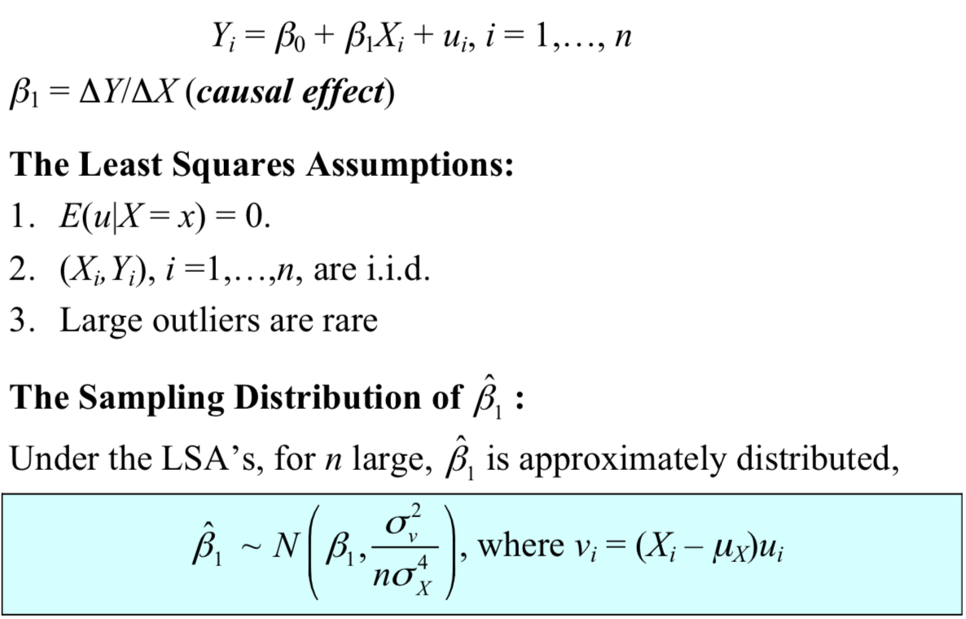
* SE(ß1-bar)
* **Hypothesis testing**
  + General approach
    - t = (estimator - hypothesized value) / (standard error of the estimator)
  + 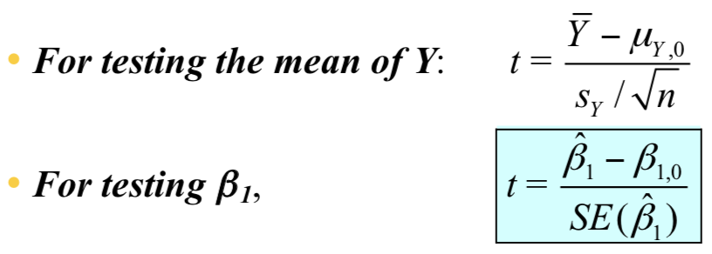
    - SE(ß1) is a square root of an estimator of the variance of the sampling distribution of ß1 (given by STATA)
  + **Reject at 5% significance level if |t| > 1.96**
  + **Reject if the p-value < 5%**